**Step 3.1: Entities and their associated attributes**

1. Ward

* Ward Number (Primary Key)
* Ward Name
* Ward Location
* Total Number of Beds
* Telephone Extension Numbers

2. Patient

* Patient Number (Primary Key)
* Patient Name
* Age
* Address
* Contact Number

3. Medication

* Medication Number (Primary Key)
* Medication Name
* Dosage
* Method of Administration
* Start Date
* Finish Date

4. Supply Item

* Item Number (Primary Key)
* Item Name
* Item Description
* Quantity in Stock
* Reorder Level
* Cost per Unit

5. Pharmaceutical Supply

* Drug Number (Primary Key)
* Drug Name
* Description
* Dosage
* Stock Levels

6. Requisition

* Requisition Number (Primary Key)
* Staff Details (e.g., Staff Number, Staff Name)
* Ward Information (e.g., Ward Number, Ward Name)
* Item/Drug Details (e.g., Item Number, Drug Number, Item Name, Drug Name)
* Cost
* Quantity Required
* Date of Order

7. Staff

* Staff Number (Primary Key)
* Staff Name
* Qualifications
* Previous Work Experience

8. Supplier

* Supplier Number (Primary Key)
* Supplier Name
* Address
* Email Contacts
* Telephone Number
* Fax Number

**Step 3.2: Relationships and descriptive attributes**

1. Ward-Patient (1:N)

* Admission Date (Descriptive attribute)

2. Ward-Medication (M:N)

* Prescription Date (Descriptive attribute)

3. Ward-Supply Item (M:N)

* Stock Update Date (Descriptive attribute)

4. Ward-Pharmaceutical Supply (M:N)

* Stock Update Date (Descriptive attribute)

5. Ward-Requisition (1:N)

* Delivery Date (Descriptive attribute)
* Charge Nurse's Signature (Descriptive attribute)

6. Staff-Ward (M:N)

* Role in the Ward (Descriptive attribute)

7. Supplier-Supply Item (M:N)

* Contract Start Date (Descriptive attribute)
* Contract End Date (Descriptive attribute)

**Step 3.3: E-R diagram representation**

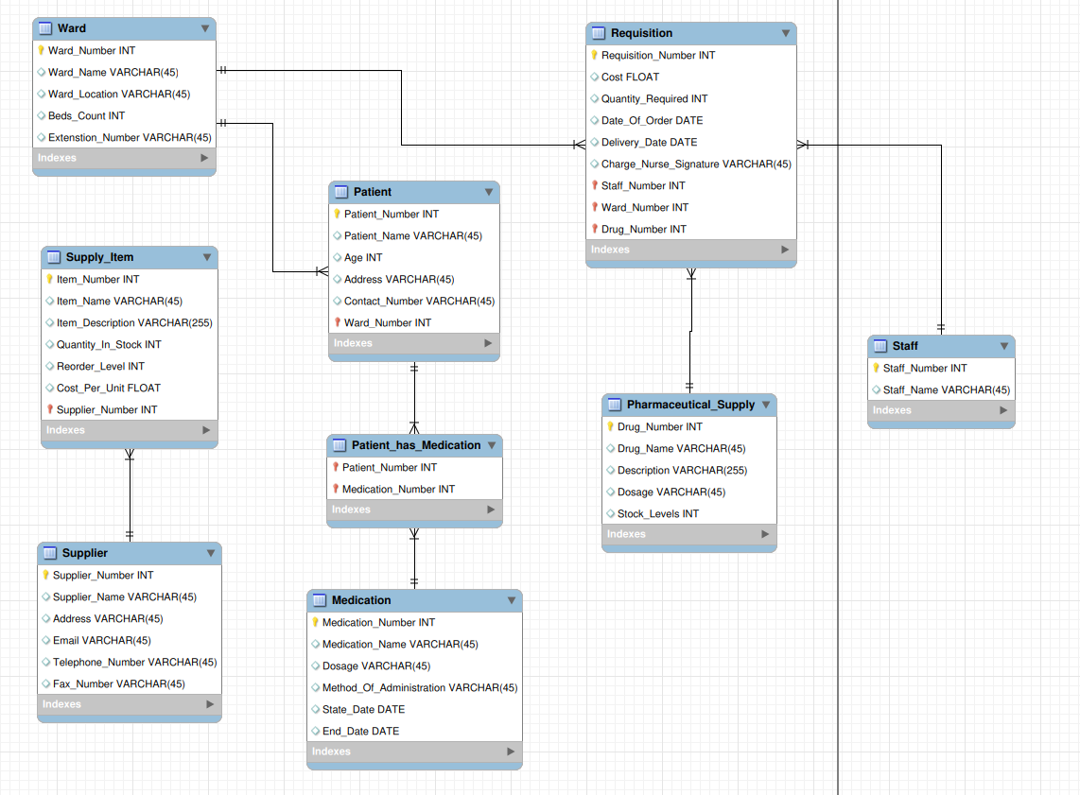

**Step 3.4: Data Dictionary and Assumptions**

* Assumption 1: Each patient is assigned to only one ward at a time.
* Assumption 2: Each medication is prescribed to multiple patients, and each patient can have multiple medications prescribed.
* Assumption 3: Each supply item and pharmaceutical supply can be used in multiple wards, and each ward can use multiple supply items and pharmaceutical supplies.
* Assumption 4: Each staff member can work in multiple wards, and each ward can have multiple staff members.
* Assumption 5: Each supplier can provide multiple supply items, and each supply item can be provided by multiple suppliers.

**Step 3.5: Database Schema**

* Ward (ward_number (PK), ward_name, ward_location, beds_count, ext_numbers)
* Patient (patient_number (PK), patient_name, age, address, contact_number)
* Medication (medication_number (PK), medication_name, dosage, method_of_admin, start_date, finish_date)
* Supply_Item (item_number (PK), item_name, item_description, quantity_in_stock, reorder_level, cost_per_unit)
* Pharmaceutical_Supply (drug_number (PK), drug_name, description, dosage, stock_levels)
* Requisition (requisition_number (PK), staff_details, ward_information, item_drug_details, cost, quantity_required, date_of_order, delivery_date, charge_nurse_signature)
* Staff (staff_number (PK), staff_name, qualifications, prev_work_experience)
* Supplier (supplier_number (PK), supplier_name, address, email_contacts, telephone_number, fax_number)